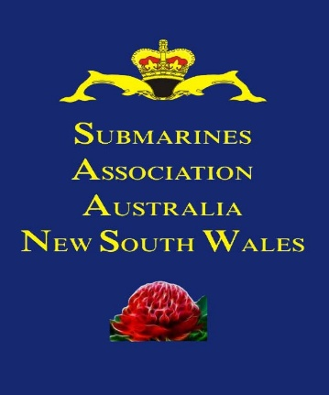 | Submarines Association Australia  NSW Branch Incorporated  INC9881573  President Geoff Anderson Phone: 0413 980 091  Hon. Vice President Warren Goodall Phone: 0413 807 596  Hon. Treasurer John Chambers Phone: 0418 184 802  Hon. Secretary Brad Mitchell Phone: 0415 105 187  Welfare Officer Geoff Roberts Phone: 0418 569 140

NSW SAA Committee Report September 2026

It is my pleasure to present the President's Report for the period July to September 2026 in lieu of a meeting.
Spectacle Island Repository
As advised at the AGM there is no change with access still to be granted even though pushed by all submarine organisations.
SUB BASE PLATYPUS Memorial
Discussions were held with the SHFT as to whether we can install Individual Plaques for departed members. Regrettably it is SHFT policy that this is not allowed. We consider this request is now closed. It was noticed that the stainless-steel plaques on the steps are fading. We have spoken to the manufacturer and sent photos for their inspection. Response as to rectification is expected shortly.
Strathfield Massacre 1991
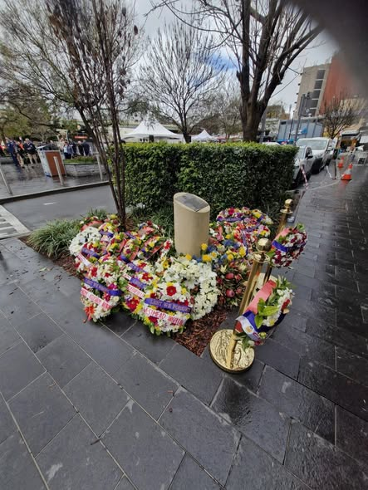 | 17 Aug I attended the 35th Anniversary of the 1991 Strathfield Massacre in support of fellow submariner Greg Read SC organised by the Cumberland RSL, attended by many First Responders and laid a wreath on behalf of the SAA.  Police estimated that Greg’s actions in alerting and warning others saved at least eight people from death or injury. He was awarded the Star of Courage in October 1992 for acts of conspicuous courage in circumstances of great peril by the Australia’s Governor-General. The Star of Courage is the second highest Australian bravery decoration

Battle of Sydney
The Annual ceremony for the battle of Sydney, midget submarine attack, was held on Friday 5 June 2026 at North Head. John Chambers attended on behalf of the SAA NSW and laid a wreath.
AE2 Services
Emerton memorial.
on Saturday 12th September 2026 at Halverson Park at Ermington AE2 and AE1 Memorial Cumberland RSL sub branch and Submarine Association Australia NSW Branch, with Tingira Australia Association, HMAS SYDNEY Association NSW and Naval Association HMAS Parramatta Memorial branch, conducted a Commemoration led by Major Matt Jones Rtd, Greg Read SC, Brad Mitchell and Brian Yeo with 45 members attending the service.
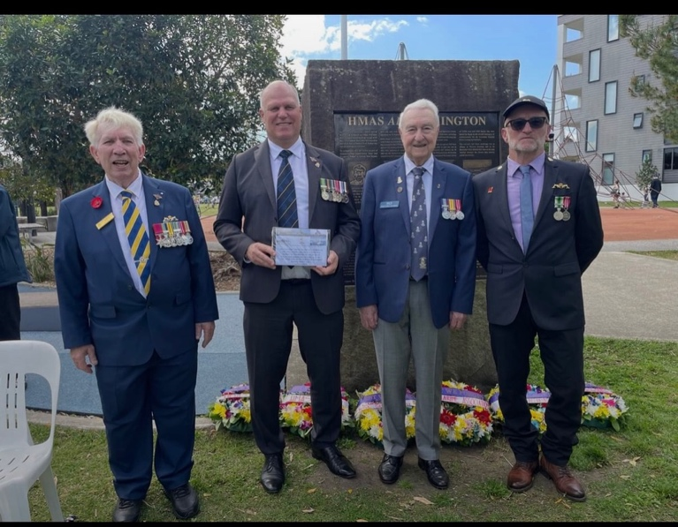

AE1 Services Sun Base Platypus
12 people attended the AE1 Memorial Service at Sub Base Platypus on 14 September under clear skys and good weather. A short memorial service was held, under Simon Hubbard, and the names of all submariners lost in service were read. Wreaths were laid by Very Ryan AE1
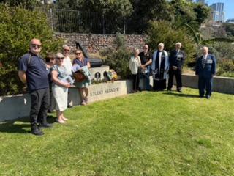 | 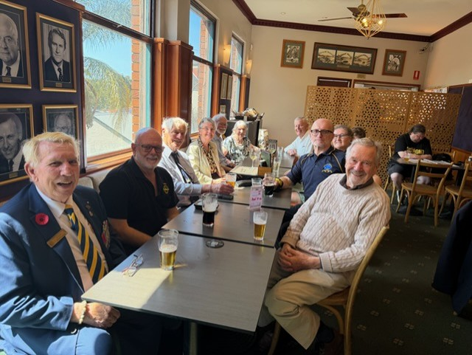

After we retired to the Kirribilli Hotel for a glass or 2 a plus lunch courtesy of the Cumberland RSL Thanks Greg, the generosity was appreciated by all.
Yellow Submarine
Cumberland RSL Subbranch is inviting all submariners to attend a Yellow Submarine Ball, with dinner and refreshments provided for serving and ex submariners including their direct family members, entry will be by wearing smart casual, but the submariner must wear a set of dolphins. There are no charges associated with this event as it is being sponsored by the subbranch.  Please contact Secretary(Brad) and I will pass on contact details for event.  CUMBERLAND RSL SUB BRANCH - YELLOW SUBMARINE BALL 2026 - 16TH OCTOBER 2026 - DOOLEYS CATHOLIC CLUB PAVILLION- REGENTS PARK - NSW 2143 | 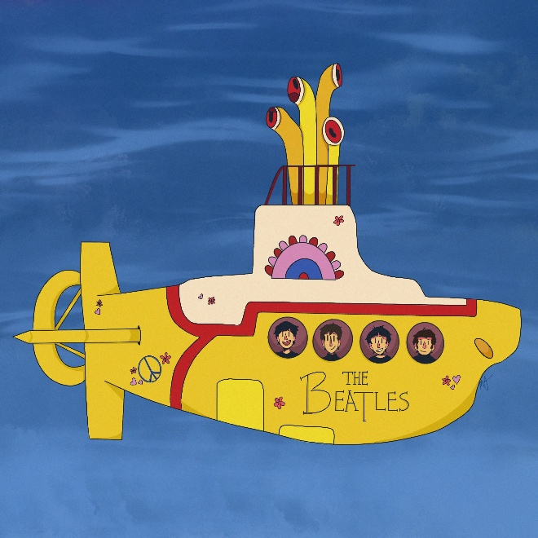

Committee Meeting 3 September - Update
- Xmas Party and General Meeting
Only three months now until the Christmas Function and the NSW Branch Meeting. To ensure we do receive the very best of discounts, please make sure you register to attend the Christmas Function and the NSW Branch Meeting asap. At present we are short of the numbers for aa private room
VENUE: Gosford RSL, 26 Central Coast Hwy, West Gosford NSW 2250
DATES & TIMES :
Saturday 5th December : Gallery Room : 6.30 pm pre-dinner drinks : 7.00 pm Dinner
Sunday 6th December : SAA NSW Branch Meeting : Gallery Room : 10.00 am
DINNER : FOOD ONLY : Cost $79 per head. Payment to treasurer.
RSVP & DIETARY REQUIREMENTS:
Please RSVP as soon as possible to our NSW Secretary, Brad, if attending.
We encourage members to support the event and bring along fellow members where possible.
- Bathurst 2027
We are also looking ahead to March next year, with plans being developed for a social gathering in Bathurst. This will be a social occasion rather than a formal meeting, and further information will be circulated once arrangements have been confirmed.
- Website and Records
Work is also underway to improve the way NSW SAA information and historical records are maintained.
The current intention is to move away from the existing standalone NSW website and eventually use a dedicated page on the national website. In the interim, efforts are being made to restore access to the existing NSW website so that information can continue to be maintained.
A cloud base account will also be established as a central repository for NSW SAA documents and records. Importantly, the account will be established using a dedicated NSW SAA Gmail address rather than an individual’s personal account. This will provide better continuity and allow future committees to take over administration of the records.
- Privacy and Information
As part of this work, the committee will review the National Communication and Information Systems Privacy Policy against information currently appearing on the NSW website.
The purpose is to ensure that information published online is appropriate and consistent with the organisation’s privacy and information-management requirements.
- Looking Forward
The committee remains focused on providing members with opportunities to meet, participate in events and maintain our connections within the submarine community.
We look forward to seeing as many members as possible at SUBCON, the Christmas gathering and future social activities.

Regards

Geoff Anderson

President
18 September 2026

